**VISVESVARAYA TECHNOLOGICAL UNIVERSITY**

**“JnanaSangama”, Belgaum -590014, Karnataka.**



**LAB REPORT**

**on**

BIG DATA ANALYTICS (20CS6PEBDA)

***Submitted by***

**MD Suraj Kumar (1BM20CS079)**

***in partial fulfillment for the award of the degree of***

**BACHELOR OF ENGINEERING**

***in***

**COMPUTER SCIENCE AND ENGINEERING**



**B.M.S. COLLEGE OF ENGINEERING**

**(Autonomous Institution under VTU)**

**BENGALURU-560019**

**May-2023 to July-2023**

**B. M. S. College of Engineering,**

**Bull Temple Road, Bangalore 560019**

(Affiliated To Visvesvaraya Technological University, Belgaum)

**Department of Computer Science and Engineering**



**CERTIFICATE**

This is to certify that the Lab work entitled “**BIG DATA ANALYTICS**” carried out by **MD Suraj Kumar (1BM20CS079),** who is a bonafide student of **B. M. S. College of Engineering.** It is in partial fulfillment for the award of **Bachelor of Engineering in Computer Science and Engineering** of the Visvesvaraya Technological University, Belgaum during the year 2022. The Lab report has been approved as it satisfies the academic requirements in respect of a Big Data Analytics - (20CS6PEBDA) work prescribed for the said degree.

**Dr.Selva Kumar S Dr. Jyothi S Nayak**

Assistant Professor Professor and Head

Department of CSE Department of CSE

BMSCE, Bengaluru BMSCE, Bengaluru

`

# Index Sheet

| **Sl.No.** | **Experiment Title** |
| --- | --- |
| **1** | **Cassandra Lab Program1: - Employee Database** |
| **2** | **Cassandra Lab Program1: - Library Database** |
| **3** | **MongoDB- CRUD Demonstration** |
| **4** | **Hadoop installation** |
| **5** | **Hadoop Commands** |
| **6** | **Hadoop Program: Average Temperature** |
| **7** | **Hadoop Program: Word Count** |
| **8** | **Hadoop program: Join operation** |
| **9** | **Scala Program** |
| **10** | **Scala Program: Word Count** |

**Course Outcome**

| CO1 | Apply the concept of NoSQL, Hadoop or Spark for a given task |
| --- | --- |
| C02 | Analyze the Big Data and obtain insight using data analytics mechanisms. |
| C03 | Design and implement big data applications by applying NoSQL, Hadoop or Spark |

# LAB – 01

## AIM: Perform the following DB operations using Cassandra.

1. Create a keyspace by name Employee
2. Create a column family by name Employee-Info with attributes Emp_Id Primary Key, Emp_Name, Designation, Date_of_Joining, Salary, Dept_Name
3. Insert the values into the table in batch
4. Update Employee name and Department of Emp-Id 121
5. Sort the details of Employee records based on salary
6. Alter the schema of the table Employee_Info to add a column Projects which stores a set of Projects done by the corresponding Employee.
7. Update the altered table to add project names.
8. Create a TTL of 15 seconds to display the values of Employees.

cqlsh:employee> CREATE KEYSPACE employee WITH REPLICATION={ 'class' : 'SimpleStrategy', 'replication_factor' : 1};

cqlsh:employee> USE employee;

cqlsh:employee> create table employee_info(emp_id int PRIMARY KEY, emp_name text,

... designation text, date_of_joining timestamp, salary double PRIMARY KEY, dept_name text);

cqlsh:employee> CREATE TABLE employee_info(emp_id int, emp_name text, designation text, date_of_joining timestamp, salary double, dept_name text, PRIMARY KEY(emp_id, salary));

cqlsh:employee> BEGIN BATCH INSERT INTO

... employee_info(emp_id,emp_name,designation,date_of_joining,salary,dept_name)

... VALUES(100,'John','MANAGER','2021-09-11',30000,'TESTING');

... INSERT INTO

... employee_info(emp_id,emp_name,designation,date_of_joining,salary,dept_name)

... VALUES(111,'Tom','ASSOCIATE','2021-06-22',25000,'DEVELOPING');

... INSERT INTO

... employee_info(emp_id,emp_name,designation,date_of_joining,salary,dept_name)

... VALUES(121,'Elsa','MANAGER','2021-03-30',35000,'HR');

... INSERT INTO

... employee_info(emp_id,emp_name,designation,date_of_joining,salary,dept_name)

... VALUES(115,'Chris','ASSISTANT','2021-12-30',20000,'DEVELOPING');

... INSERT INTO

... employee_info(emp_id,emp_name,designation,date_of_joining,salary,dept_name)

... VALUES(105,'Sarah','ASSOCIATE','2021-06-25',25000,'TESTING');

... APPLY BATCH;

cqlsh:employee> SELECT * FROM employee_info

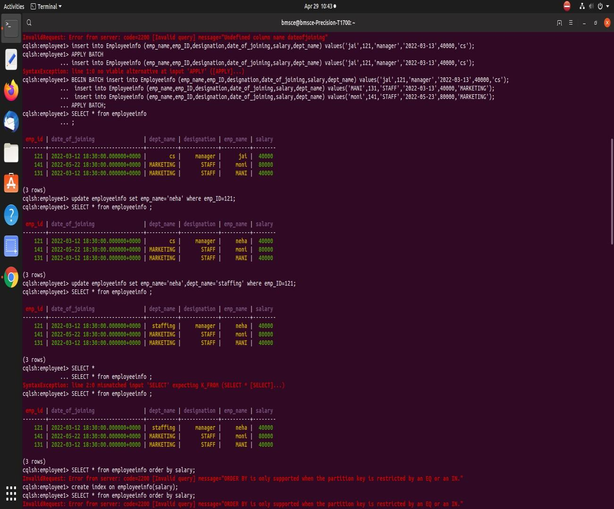

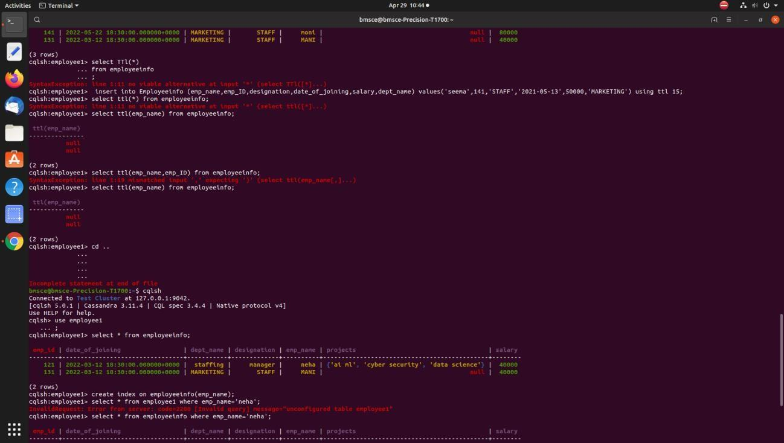

# LAB – 02

**AIM- Perform the following DB operations using Cassandra**. 1.Create a keyspace by name Library

1. Create a column family by name Library-Info with attributes Stud_Id Primary Key, Counter_value of type Counter, Stud_Name, Book-Name, Book-Id, Date_of_issue
2. Insert the values into the table in batch
3. Display the details of the table created and increase the value of the counter 5. Write a query to show that a student with id 112 has taken a book “BDA” 2 times. 6. Export the created column to a csv file

7. Import a given csv dataset from local file system into Cassandra column family

1. cqlsh:library> CREATE KEYSPACE library WITH replication = {'class': 'SimpleStrategy','replication_factor':1}; cqlsh:library> USE library ;

cqlsh:library> CREATE TABLE Library_info(stud_id int, stud_name text, book_name text, book_id text, date_of_issue timestamp, counter_value counter, PRIMARY KEY(stud_id,stud_name, book_name, book_id, date_of_issue));

cqlsh:library> BEGIN COUNTER BATCH

... UPDATE library_info set counter_value +=1 where stud_id = 111 and stud_name = 'Manoj' and book_name = 'Operations Research' and book_id = '56TXT' and date_of_issue = '2021-09-12';

... UPDATE library_info set counter_value +=1 where stud_id = 112 and stud_name = 'Kamal' and book_name = 'Engineering Mathematics-3' and book_id = '5ERW4' and date_of_issue = '2021-04-10';

... UPDATE library_info set counter_value +=1 where stud_id = 113 and stud_name = 'Mahesh' and book_name = 'Robinson Crusoe' and book_id = '34EDC' and date_of_issue = '2021-02-01';

... UPDATE library_info set counter_value +=1 where stud_id = 114 and stud_name = 'Raj' and book_name = 'Engineering Drawing' and book_id = '123ER' and date_of_issue = '2021-04-03';

... APPLY BATCH;

cqlsh:library> SELECT * FROM library_info ;

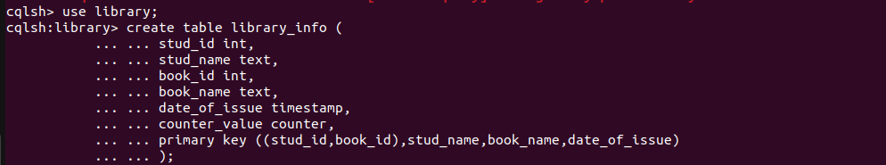

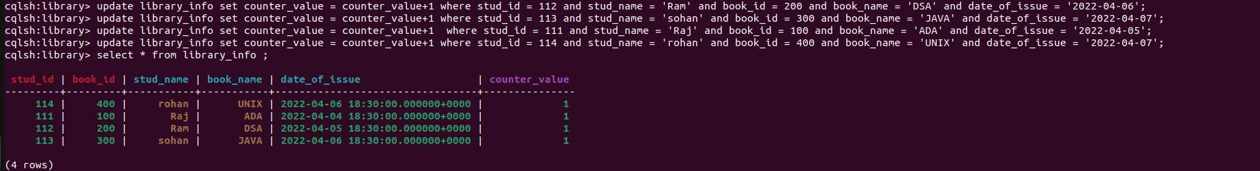

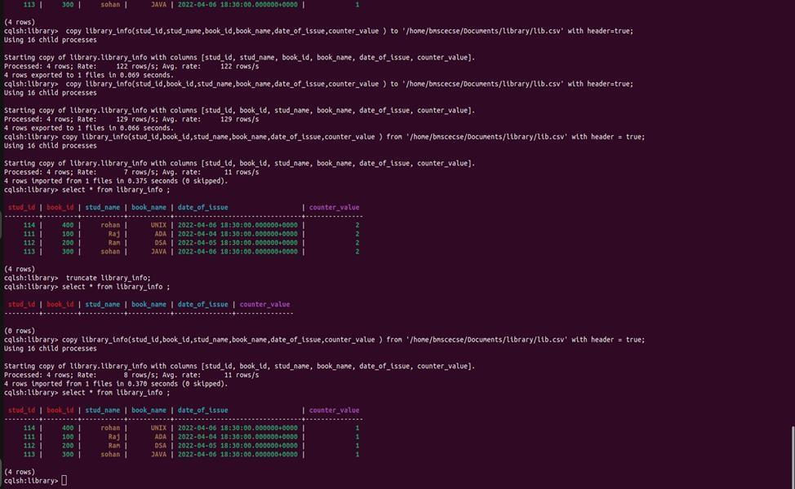

# LAB – 03

**AIM- MongoDB- CRUD Demonstration:**

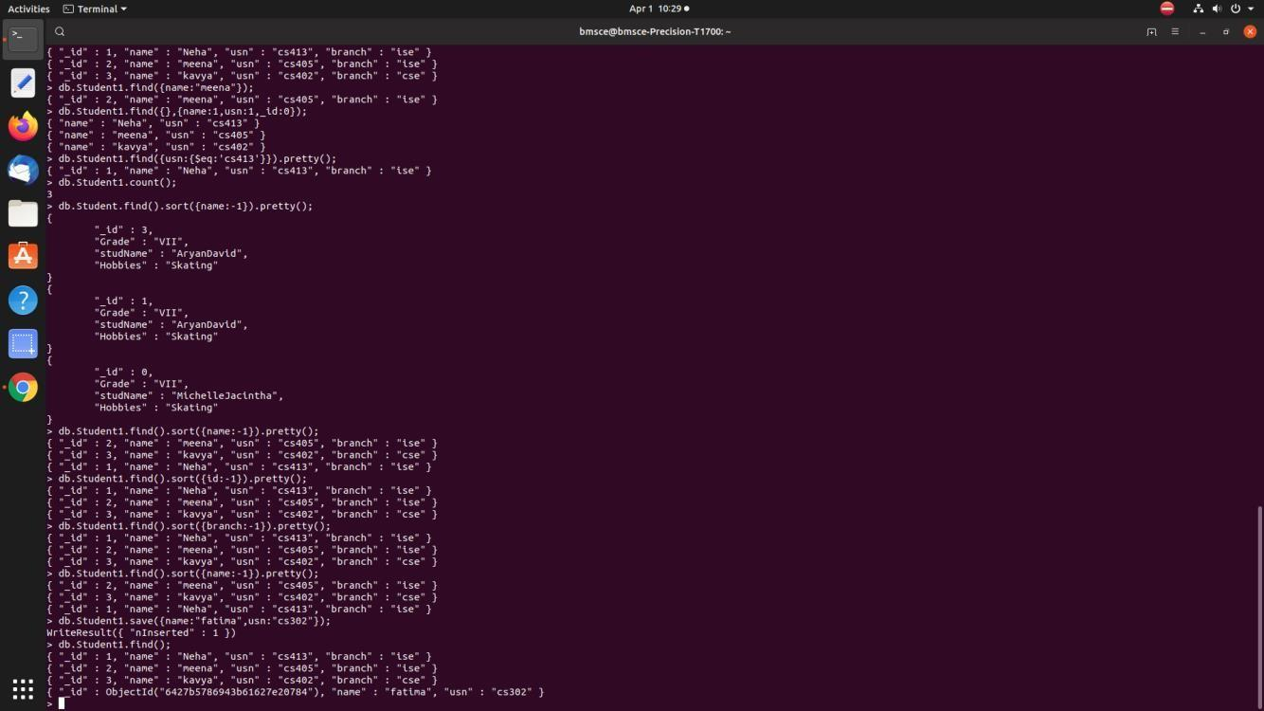

bmsce@bmsce-Precision-T1700:~$ mongo MongoDB shell version v3.6.8

connecting to: mongodb://127.0.0.1:27017

Implicit session: session { "id" : UUID("d66acdb3-8482-417d-8b75-d65dae4b53ee") } MongoDB server version: 3.6.8

* use Student switched to db Student
* db.createCollection("student");

{ "ok" : 1 }

* db.Student.insert({_id:1,StudName:"Megha",Grade:"vii",Hobbies:"InternetSurfing"}); WriteResult({ "nInserted" : 1 })
* db.Student.update({_id:3,StudName:"Ayan",Grade:"vii"},{$set:{Hobbies:"skating"}},{upsert:true}); WriteResult({ "nMatched" : 0, "nUpserted" : 1, "nModified" : 0, "_id" : 3 })
* db.Student.find({StudName:"Ayan"}

{ "_id" : 3, "Grade" : "vii", "StudName" : "Ayan", "Hobbies" : "skating" }

* db.Student.find({},{StudName:1,Grade:1,_id:0});

{ "StudName" : "Megha", "Grade" : "vii" }

{ "Grade" : "vii", "StudName" : "Ayan" }

* db.Student.find({Grade:{$eq:'vii'}}).pretty();

{

"_id" : 1,

"StudName" : "Megha",

"Grade" : "vii",

"Hobbies" : "InternetSurfing"

}

{ "_id" : 3, "Grade" : "vii", "StudName" : "Ayan", "Hobbies" : "skating" }

* db.Student.find({Grade:{$eq:'vii'}});

{ "_id" : 1, "StudName" : "Megha", "Grade" : "vii", "Hobbies" : "InternetSurfing" }

{ "_id" : 3, "Grade" : "vii", "StudName" : "Ayan", "Hobbies" : "skating" }

* db.Student.find({Grade:{$eq:'vii'}}).pretty();

{

"_id" : 1,

"StudName" : "Megha",

"Grade" : "vii",

"Hobbies" : "InternetSurfing"

}

{ "_id" : 3, "Grade" : "vii", "StudName" : "Ayan", "Hobbies" : "skating" }

* db.Student.find({Hobbies:{$in:['Chess','Skating']}}).pretty();
* db.Student.find({Hobbies:{$in:['Skating']}}).pretty();
* db.Student.find({Hobbies:{$in:['skating']}}).pretty();

{ "_id" : 3, "Grade" : "vii", "StudName" : "Ayan", "Hobbies" : "skating" }

* db.Student.find({StudName:/^M/}).pretty();

{

"_id" : 1,

"StudName" : "Megha",

"Grade" : "vii",

"Hobbies" : "InternetSurfing"

}

* db.Student.find({StudName:/e/}).pretty();

{

"_id" : 1,

"StudName" : "Megha",

"Grade" : "vii",

"Hobbies" : "InternetSurfing"

}

* db.Student.count(); 2
* db.Student.find().sort({StudName:-1}).pretty();

{

"_id" : 1,

"StudName" : "Megha",

"Grade" : "vii",

"Hobbies" : "InternetSurfing"

}

{ "_id" : 3, "Grade" : "vii", "StudName" : "Ayan", "Hobbies" : "skating" }

* db.Student.save({StudName:"Vamsi",Greade:"vi"}) WriteResult({ "nInserted" : 1 })
* db.Students.update({_id:4},{$set:{Location:"Network"}}) WriteResult({ "nMatched" : 0, "nUpserted" : 0, "nModified" : 0 })
* db.Students.update({_id:4},{$unset:{Location:"Network"}}) WriteResult({ "nMatched" : 0, "nUpserted" : 0, "nModified" : 0 })
* db.Student.find({_id:1},{StudName:1,Grade:1,_id:0});

{ "StudName" : "Megha", "Grade" : "vii" }

* db.Student.find({Grade:{$ne:'VII'}}).pretty();

{

"_id" : 1,

"StudName" : "Megha",

"Grade" : "vii",

"Hobbies" : "InternetSurfing"

}

{ "_id" : 3, "Grade" : "vii", "StudName" : "Ayan", "Hobbies" : "skating" }

{

"_id" : ObjectId("6253f413e88b8c9e787b194e"), "StudName" : "Vamsi",

"Grade" : "vi"

}

* db.Student.find({StudName:/s$/}).pretty();
* db.Students.update({_id:3},{$set:{Location:null}}) WriteResult({ "nMatched" : 0, "nUpserted" : 0, "nModified" : 0 })
* db.Students.count() 0
* db.Students.count({Grade:"VII"}) 0
* db.Student.find({Grade:"VII"}).limit(3).pretty();
* db.Student.update({_id:3},{$set:{Location:null}})

WriteResult({ "nMatched" : 1, "nUpserted" : 0, "nModified" : 1 })

> db.Student.count({Grade:"VII"})

0

* db.Students.count({Grade:"vii"}) 0
* db.Student.count() 3
* db.Student.count({Grade:"vii"}) 2
* db.Student.find({Grade:"vii"}).limit(3).pretty();

{

"_id" : 1,

"StudName" : "Megha",

"Grade" : "vii",

"Hobbies" : "InternetSurfing"

}

{

"_id" : 3, "Grade" : "vii",

"StudName" : "Ayan", "Hobbies" : "skating", "Location" : null

}

* db.Student.find().sort({StudName:1}).pretty();

{

"_id" : 3, "Grade" : "vii",

"StudName" : "Ayan", "Hobbies" : "skating",

"Location" : null

}

{

"_id" : 1,

"StudName" : "Megha",

"Grade" : "vii",

"Hobbies" : "InternetSurfing"

}

{

"_id" : ObjectId("6253f413e88b8c9e787b194e"), "StudName" : "Vamsi",

"Grade" : "vi"

}

* db.Student.find().skip(2).pretty()

{

"_id" : ObjectId("6253f413e88b8c9e787b194e"), "StudName" : "Vamsi",

"Grade" : "vi"

}

* db.food.insert( { _id:1, fruits:['grapes','mango','apple';] } )

2022-04-11T15:05:51.894+0530 E QUERY [thread1] SyntaxError: missing ] after element list @(shell):1:57

* db.food.insert({_id:1,fruits:['grapes','mango','apple']}) WriteResult({ "nInserted" : 1 })
* db.food.insert({_id:2,fruits:['grapes','mango','cherry']}) WriteResult({ "nInserted" : 1 })
* db.food.insert({_id:3,fruits:['banana','mango']}) WriteResult({ "nInserted" : 1 })
* db.food.find({fruits:['grapes','mango','apple']}).pretty();

{ "_id" : 1, "fruits" : [ "grapes", "mango", "apple" ] }

* db.food.find({'fruits.1':'grapes'})
* db.food.find({"fruits":{$size:2}})

{ "_id" : 3, "fruits" : [ "banana", "mango" ] }

* db.food.find({_id:1},{"fruits":{$slice:2}})

{ "_id" : 1, "fruits" : [ "grapes", "mango" ] }

* db.food.find({fruits:{$all:["mango","grapes"]}})

{ "_id" : 1, "fruits" : [ "grapes", "mango", "apple" ] }

{ "_id" : 2, "fruits" : [ "grapes", "mango", "cherry" ] }

* db.food.update({_id:3},{$set:{"fruits.1":"apple"}}) WriteResult({ "nMatched" : 1, "nUpserted" : 0, "nModified" : 1 })
* db.food.update({_id:2},{$push:{price:{grapes:80,mango:200,cherry:100}}}) WriteResult({ "nMatched" : 1, "nUpserted" : 0, "nModified" : 1 })

>db.Customers.insert({_custID:1,AcctBal:'100000',AcctType:"saving"}); WriteResult({ "nInserted" : 1 })

* db.Customers.aggregate({$group:{_id:"$custID",TotAccBal:{$sum:"$AccBal"}}});

{ "_id" : null, "TotAccBal" : 0 } db.Customers.aggregate({$match:{AcctType:"saving"}},{$group:{_id:"$custID",TotAccBal:{$sum:"$AccBal"}}});

{ "_id" : null, "TotAccBal" : 0 }

db.Customers.aggregate({$match:{AcctType:"saving"}},{$group:{_id:"$custID",TotAccBal:{$sum:"$AccBal"}}},{$ match:{TotAccBal:{$gt:1200}}

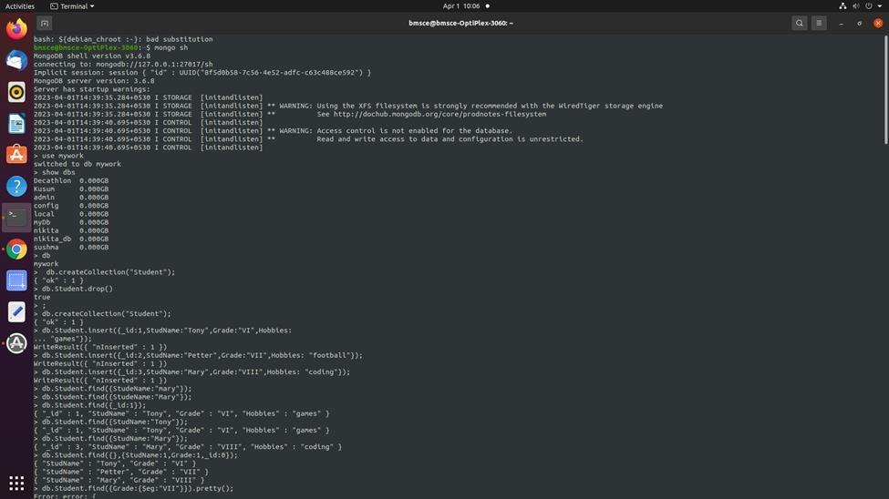

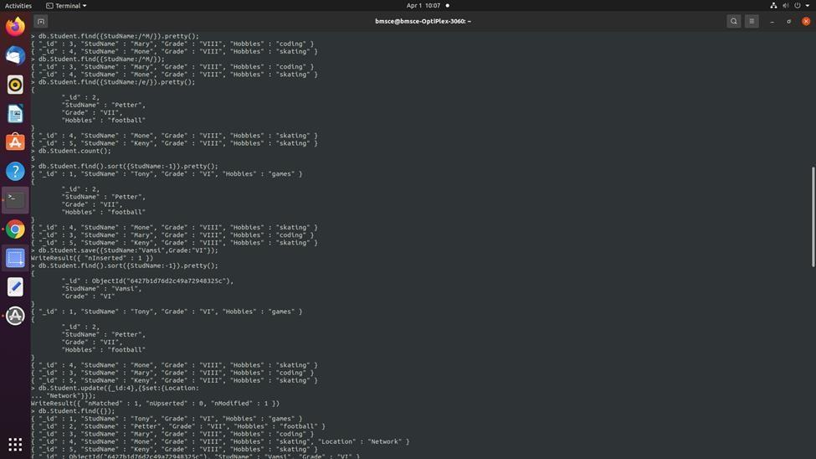

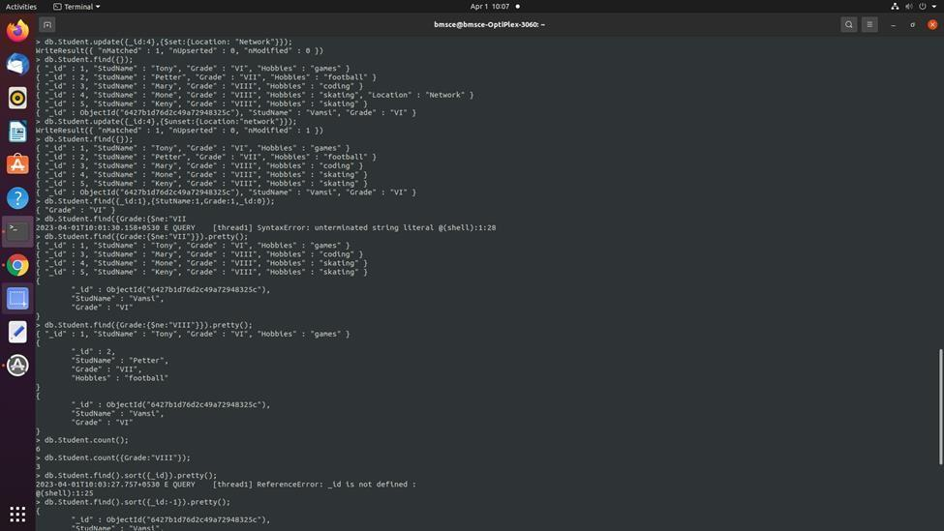

# LAB – 04

**AIM- Screenshot of Hadoop Installed**

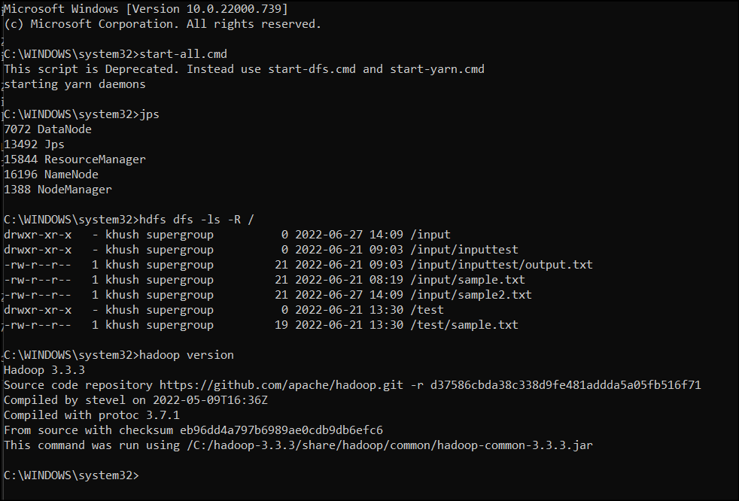

# LAB – 05

**AIM- Execution of HDFS Commands for Interaction with Hadoop**

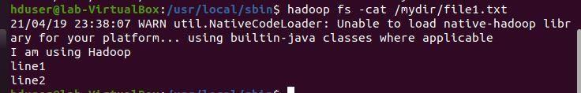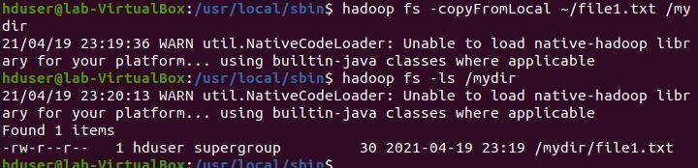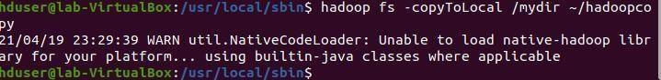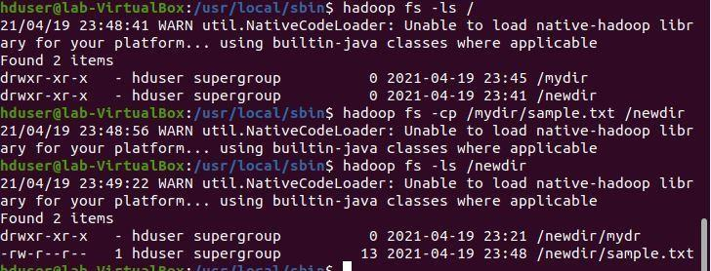



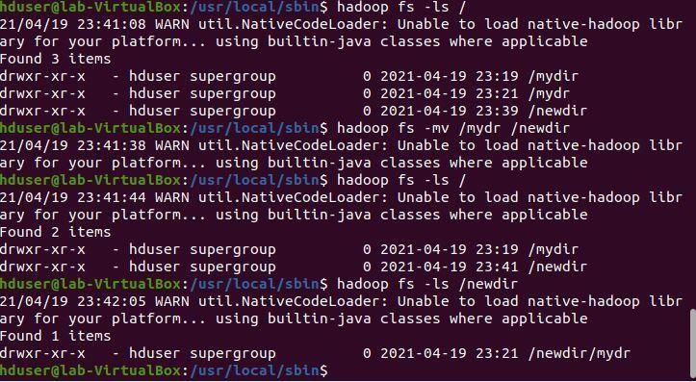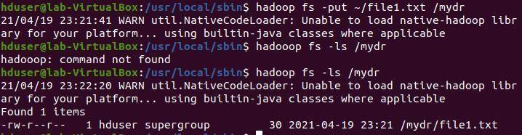

# LAB – 06

## AIM-Create a Map Reduce program to

1. find average temperature for each year from the NCDC data set.

**AverageDriver** package temp;

import org.apache.hadoop.fs.Path; import org.apache.hadoop.io.IntWritable; import org.apache.hadoop.io.Text;

import org.apache.hadoop.mapreduce.Job;

import org.apache.hadoop.mapreduce.lib.input.FileInputFormat; import org.apache.hadoop.mapreduce.lib.output.FileOutputFormat; public class AverageDriver { public static void main(String[] args) throws Exception {

if (args.length != 2) {

System.err.println("Please Enter the input and output parameters"); System.exit(-1);

}

Job job = new Job(); job.setJarByClass(AverageDriver.class);

job.setJobName("Max temperature"); FileInputFormat.addInputPath(job, new Path(args[0])); FileOutputFormat.setOutputPath(job, new Path(args[1])); job.setMapperClass(AverageMapper.class); job.setReducerClass(AverageReducer.class);23 job.setOutputKeyClass(Text.class); job.setOutputValueClass(IntWritable.class); System.exit(job.waitForCompletion(true) ? 0 : 1);

}}

**AverageMapper** package temp;

import java.io.IOException;

import org.apache.hadoop.io.IntWritable; import org.apache.hadoop.io.LongWritable;

import org.apache.hadoop.io.Text;

import org.apache.hadoop.mapreduce.Mapper;

public class AverageMapper extends Mapper<LongWritable, Text, Text, IntWritable> { public static final int MISSING = 9999;

public void map(LongWritable key, Text value, Mapper<LongWritable, Text, Text, IntWritable>.Context context) throws IOException, InterruptedException {

int temperature;

String line = value.toString(); String year = line.substring(15, 19); if (line.charAt(87) == '+') {

temperature = Integer.parseInt(line.substring(88, 92));

} else {

temperature = Integer.parseInt(line.substring(87, 92));

}

String quality = line.substring(92, 93);24

if (temperature != 9999 && quality.matches("[01459]")) context.write(new Text(year), new IntWritable(temperature));

}

}

**AverageReducer** package temp;

import java.io.IOException;

import org.apache.hadoop.io.IntWritable; import org.apache.hadoop.io.Text;

import org.apache.hadoop.mapreduce.Reducer;

public class AverageReducer extends Reducer<Text, IntWritable, Text, IntWritable> { public void

reduce(Text key, Iterable<IntWritable> values, Reducer<Text, IntWritable, Text,

IntWritable>.Context context) throws IOException, InterruptedException { int max_temp = 0;

int count = 0;

for (IntWritable value : values) { max_temp += value.get(); count++;

}

context.write(key, new IntWritable(max_temp / count));

}

}

**OUTPUT-**

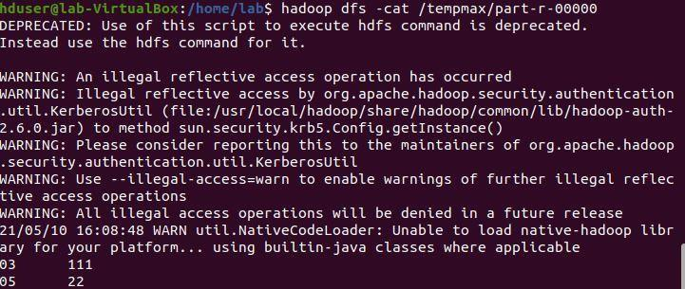

1. **find the mean max temperature for every** month MeanMaxDriver

MeanMaxDriver.class package meanmax;

import org.apache.hadoop.fs.Path; import org.apache.hadoop.io.IntWritable; import org.apache.hadoop.io.Text;

import org.apache.hadoop.mapreduce.Job;

import org.apache.hadoop.mapreduce.lib.input.FileInputFormat; import org.apache.hadoop.mapreduce.lib.output.FileOutputFormat; public class MeanMaxDriver { public static void main(String[] args) throws Exception {

if (args.length != 2) {

System.err.println("Please Enter the input and output parameters"); System.exit(-1);

}

Job job = new Job(); job.setJarByClass(MeanMaxDriver.class); job.setJobName("Max temperature");

FileInputFormat.addInputPath(job, new Path(args[0])); FileOutputFormat.setOutputPath(job, new Path(args[1])); job.setMapperClass(MeanMaxMapper.class); job.setReducerClass(MeanMaxReducer.class);

job.setOutputKeyClass(Text.class); job.setOutputValueClass(IntWritable.class); System.exit(job.waitForCompletion(true) ? 0 : 1);

}

}

MeanMax Mapper **MeanMaxMapper.class** package meanmax;

import java.io.IOException;

import org.apache.hadoop.io.IntWritable; import org.apache.hadoop.io.LongWritable; import org.apache.hadoop.io.Text;

import org.apache.hadoop.mapreduce.Mapper;

public class MeanMaxMapper extends Mapper<LongWritable, Text, Text, IntWritable> { public static final int MISSING = 9999;

public void map(LongWritable key, Text value, Mapper<LongWritable, Text, Text,IntWritable>.Context context) throws IOException, InterruptedException

{ int temperature;

String line = value.toString();

String month = line.substring(19, 21); if (line.charAt(87) == '+') {

temperature = Integer.parseInt(line.substring(88, 92));

} else {

temperature = Integer.parseInt(line.substring(87, 92));

}

String quality = line.substring(92, 93);

if (temperature != 9999 && quality.matches("[01459]")) context.write(new Text(month), new IntWritable(temperature));

}

}

**MeanMax Reducer** MeanMaxReducer.class package meanmax;

import java.io.IOException;

import org.apache.hadoop.io.IntWritable; import org.apache.hadoop.io.Text;

import org.apache.hadoop.mapreduce.Reducer;

public class MeanMaxReducer extends Reducer<Text, IntWritable, Text, IntWritable> { public void reduce(Text key, Iterable<IntWritable> values, Reducer<Text, IntWritable, Text, IntWritable>.Context context) throws IOException, InterruptedException {

int max_temp = 0;

int total_temp = 0; int count = 0;

int days = 0;

for (IntWritable value : values) { int temp = value.get(); if (temp > max_temp) max_temp = temp;

count++;

if (count == 3) { total_temp += max_temp; max_temp = 0;

count = 0; days++;

}

}

context.write(key, new IntWritable(total_temp / days)); }

} **OUTPUT-**

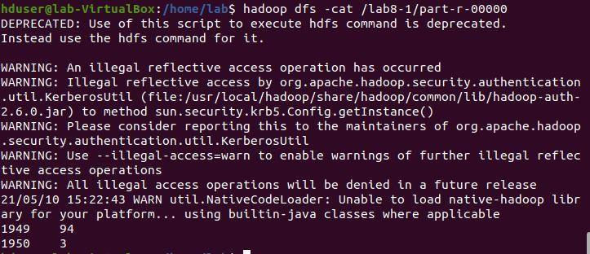

# LAB – 07

## AIM- For a given Text file, Create a Map Reduce program to sort the content in an alphabetic order listing only top 10 maximum occurrences of words.

**Driver Code** package wordCount;

import java.io.IOException;

import org.apache.hadoop.conf.Configured; import org.apache.hadoop.fs.Path;

import org.apache.hadoop.io.IntWritable; import org.apache.hadoop.io.Text;

import org.apache.hadoop.mapred.FileInputFormat; import org.apache.hadoop.mapred.FileOutputFormat; import org.apache.hadoop.mapred.JobClient;

import org.apache.hadoop.mapred.JobConf; import org.apache.hadoop.util.Tool;

import org.apache.hadoop.util.ToolRunner;

public class WCDriver extends Configured implements Tool { public int run(String args[]) throws IOException29

{

if (args.length < 2)

{

System.out.println("Please give valid inputs"); return -1;

}

JobConf conf = new JobConf(WCDriver.class); FileInputFormat.setInputPaths(conf, new Path(args[0])); FileOutputFormat.setOutputPath(conf, new Path(args[1])); conf.setMapperClass(WCMapper.class);

conf.setReducerClass(WCReducer.class); conf.setMapOutputKeyClass(Text.class); conf.setMapOutputValueClass(IntWritable.class); conf.setOutputKeyClass(Text.class); conf.setOutputValueClass(IntWritable.class); JobClient.runJob(conf);

return 0;

}

// Main Method

public static void main(String args[]) throws Exception

{

int exitCode = ToolRunner.run(new WCDriver(), args); System.out.println(exitCode);

}

}

**Mapper Code**

package wordCount;30

import java.io.IOException;

import org.apache.hadoop.io.IntWritable; import org.apache.hadoop.io.LongWritable; import org.apache.hadoop.io.Text;

import org.apache.hadoop.mapred.MapReduceBase; import org.apache.hadoop.mapred.Mapper;

import org.apache.hadoop.mapred.OutputCollector; import org.apache.hadoop.mapred.Reporter;

public class WCMapper extends MapReduceBase implements Mapper<LongWritable,Text, Text, IntWritable> {

// Map function

public void map(LongWritable key, Text value, OutputCollector<Text, IntWritable> output,

Reporter

rep) throws IOException

{

String line = value.toString();

// Splitting the line on spaces for (String word : line.split(" "))

{

if (word.length() > 0)

{

output.collect(new Text(word), new IntWritable(1));

}

}

}

}

**Reducer Code** package wordCount;

import java.io.IOException; import java.util.Iterator;

import org.apache.hadoop.io.IntWritable; import org.apache.hadoop.io.Text;

import org.apache.hadoop.mapred.MapReduceBase; import org.apache.hadoop.mapred.OutputCollector; import org.apache.hadoop.mapred.Reducer;

import org.apache.hadoop.mapred.Reporter;

public class WCReducer extends MapReduceBase implements Reducer<Text,IntWritable, Text, IntWritable> {

// Reduce function

public void reduce(Text key, Iterator<IntWritable> value, OutputCollector<Text, IntWritable>

output,Reporter rep) throws IOException

{

int count = 0;

// Counting the frequency of each words while (value.hasNext())

{

IntWritable i = value.next(); count += i.get();

}

output.collect(key, new IntWritable(count));

}

} OUTPUT-

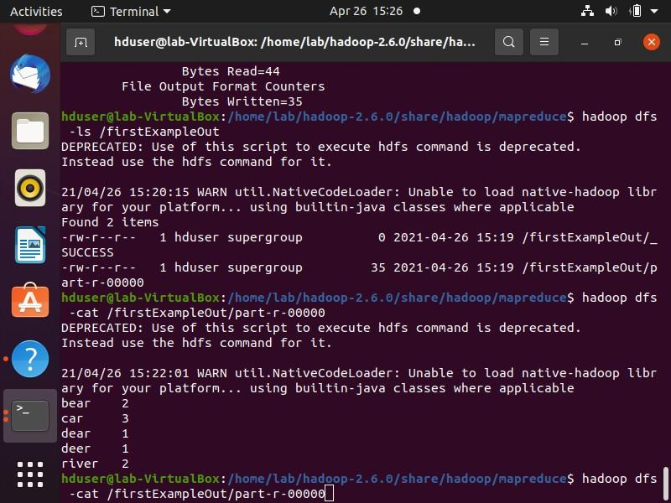

# LAB – 08

## AIM- Create a Map Reduce program to demonstrating join operation

**JoinDriver.java**

import org.apache.hadoop.conf.Configured; import org.apache.hadoop.fs.Path;

import org.apache.hadoop.io.Text; import org.apache.hadoop.mapred.*;

import org.apache.hadoop.mapred.lib.MultipleInputs; import org.apache.hadoop.util.*;

public class JoinDriver extends Configured implements Tool {

public static class KeyPartitioner implements Partitioner<TextPair, Text> { @Override

public void configure(JobConf job) {} @Override

public int getPartition(TextPair key, Text value, int numPartitions) { return (key.getFirst().hashCode() & Integer.MAX_VALUE) % numPartitions;

}

}

@Override

public int run(String[] args) throws Exception { if (args.length != 3) {

System.out.println("Usage: <Department Emp Strength input>

<Department Name input> <output>"); return -1;

}40

JobConf conf = new JobConf(getConf(), getClass());

conf.setJobName("Join 'Department Emp Strength input' with 'Department Nameinput'"); Path AInputPath = new Path(args[0]);

Path BInputPath = new Path(args[1]); Path outputPath = new Path(args[2]);

MultipleInputs.addInputPath(conf, AInputPath, TextInputFormat.class, Posts.class); MultipleInputs.addInputPath(conf, BInputPath, TextInputFormat.class, User.class); FileOutputFormat.setOutputPath(conf, outputPath); conf.setPartitionerClass(KeyPartitioner.class); conf.setOutputValueGroupingComparator(TextPair.FirstComparator.class); conf.setMapOutputKeyClass(TextPair.class); conf.setReducerClass(JoinReducer.class);

conf.setOutputKeyClass(Text.class); JobClient.runJob(conf);

return 0;

}

public static void main(String[] args) throws Exception { int exitCode = ToolRunner.run(new JoinDriver(), args); System.exit(exitCode);

}

}

**JoinReducer.java**

import java.io.IOException; import java.util.Iterator;41

import org.apache.hadoop.io.Text; import org.apache.hadoop.mapred.*;

public class JoinReducer extends MapReduceBase implements Reducer<TextPair, Text, Text, Text> {

@Override

public void reduce (TextPair key, Iterator<Text> values, OutputCollector<Text, Text>output, Reporter reporter)

throws IOException

{

Text nodeId = new Text(values.next()); while (values.hasNext()) {

Text node = values.next();

Text outValue = new Text(nodeId.toString() + "\t\t" + node.toString()); output.collect(key.getFirst(), outValue);

}

}

}

**User.java**

import java.io.IOException; import java.util.Iterator;

import org.apache.hadoop.conf.Configuration; import org.apache.hadoop.fs.FSDataInputStream; import org.apache.hadoop.fs.FSDataOutputStream; import org.apache.hadoop.fs.FileSystem;

import org.apache.hadoop.fs.Path;

import org.apache.hadoop.io.LongWritable;42 import org.apache.hadoop.io.Text;

import org.apache.hadoop.mapred.*; import org.apache.hadoop.io.IntWritable;

public class User extends MapReduceBase implements Mapper<LongWritable, Text, TextPair, Text> {

@Override

public void map(LongWritable key, Text value, OutputCollector<TextPair, Text> output, Reporter reporter)

throws IOException

{

String valueString = value.toString();

String[] SingleNodeData = valueString.split("\t"); output.collect(new TextPair(SingleNodeData[0], "1"), new Text(SingleNodeData[1]));

}

}

**Posts.java**

import java.io.IOException; import org.apache.hadoop.io.*;

import org.apache.hadoop.mapred.*;

public class Posts extends MapReduceBase implements Mapper<LongWritable, Text, TextPair, Text> {

@Override

public void map(LongWritable key, Text value, OutputCollector<TextPair, Text> output, Reporter reporter)

throws IOException43

{

String valueString = value.toString();

String[] SingleNodeData = valueString.split("\t"); output.collect(new TextPair(SingleNodeData[3], "0"), new Text(SingleNodeData[9]));

}

}

**TextPair.java** import java.io.*;

import org.apache.hadoop.io.*;

public class TextPair implements WritableComparable<TextPair> {

private Text first; private Text second; public TextPair() {

set(new Text(), new Text());

}

public TextPair(String first, String second) { Set(new Text(first), new Text(second));

}

public TextPair(Text first, Text second) { set(first, second);

}

public void set(Text first, Text second) { this.first = first;

this.second = second;

}

public Text getFirst() { return first;44

}

public Text getSecond() { return second;

}

@Override

public void write(DataOutput out) throws IOException { first.write(out);

second.write(out);

}

@Override

public void readFields(DataInput in) throws IOException {

first.readFields(in); second.readFields(in);

}

@Override

public int hashCode() {

return first.hashCode() * 163 + second.hashCode();

}

@Override

public boolean equals(Object o) { if (o instanceof TextPair) { TextPair tp = (TextPair) o;

return first.equals(tp.first) && second.equals(tp.second);

}

return false;

}

@Override

public String toString() {45 return first + "\t" + second;

}

@Override

public int compareTo(TextPair tp) { int cmp = first.compareTo(tp.first); if (cmp != 0) {

return cmp;

}

return second.compareTo(tp.second);

}

// ^^ TextPair

// vv TextPairComparator

public static class Comparator extends WritableComparator {

private static final Text.Comparator TEXT_COMPARATOR = new Text.Comparator(); public Comparator() {

super(TextPair.class);

}

@Override

public int compare(byte[] b1, int s1, int l1, byte[] b2, int s2, int l2) { try {

int firstL1 = WritableUtils.decodeVIntSize(b1[s1]) + readVInt(b1, s1); int firstL2 = WritableUtils.decodeVIntSize(b2[s2]) + readVInt(b2, s2);

int cmp = TEXT_COMPARATOR.compare(b1, s1, firstL1, b2, s2, firstL2); if (cmp != 0) {

return cmp;

}

return TEXT_COMPARATOR.compare(b1, s1 + firstL1, l1 - firstL1,46 b2, s2 + firstL2, l2 - firstL2);

} catch (IOException e) {

throw new IllegalArgumentException(e);

}

}

}

static {

WritableComparator.define(TextPair.class, new Comparator());

}

public static class FirstComparator extends WritableComparator {

private static final Text.Comparator TEXT_COMPARATOR = new Text.Comparator(); public FirstComparator() {

super(TextPair.class);

}

@Override

public int compare(byte[] b1, int s1, int l1, byte[] b2, int s2, int l2) { try {

int firstL1 = WritableUtils.decodeVIntSize(b1[s1]) + readVInt(b1, s1); int firstL2 = WritableUtils.decodeVIntSize(b2[s2]) + readVInt(b2, s2); return TEXT_COMPARATOR.compare(b1, s1, firstL1, b2, s2, firstL2);

} catch (IOException e) {

throw new IllegalArgumentException(e);

}

}

@Override

public int compare(WritableComparable a, WritableComparable b) { if (a instanceof TextPair && b instanceof TextPair) {47

return ((TextPair) a).first.compareTo(((TextPair) b).first);

}

return super.compare(a, b);

}

} } OUTPUT –

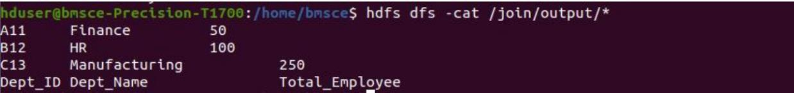

# LAB – 09

## AIM - Program to print word count on scala shell and print “Hello world” on scala IDE

val data=sc.textFile("sparkdata.txt") data.collect;

val splitdata = data.flatMap(line => line.split(" ")); splitdata.collect;

val mapdata = splitdata.map(word => (word,1)); mapdata.collect;

val reducedata = mapdata.reduceByKey(_+_); reducedata.collect;

**OUTPUT –**

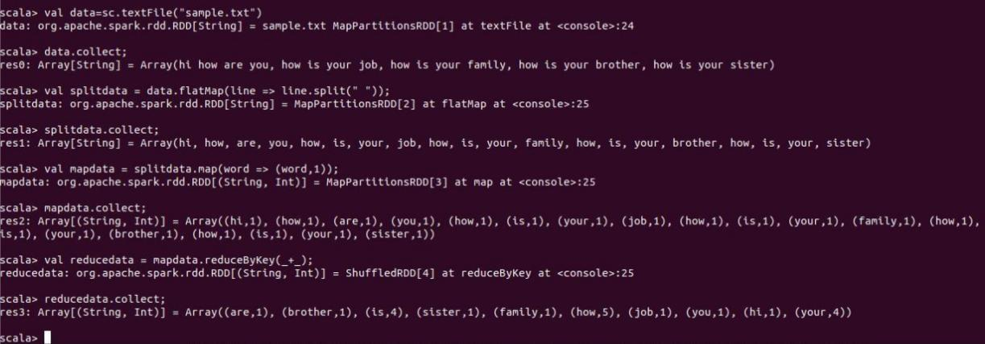

# LAB – 10

## AIM - Using RDD and FlaMap count how many times each word appears in a file and write out a list of words whose count is strictly greater than 4 using Spark

val textFile = sc.textFile("/home/bhoom/Desktop/wc.txt")

val counts = textFile.flatMap(line => line.split(" ")).map(word => (word, 1)).reduceByKey(_+_) import scala.collection.immutable.ListMap

val sorted=ListMap(counts.collect.sortWith(_._2 > _._2):_*)// sort in descending order based on values

println(sorted) for((k,v)<-sorted) { if(v>4) { print(k+",") print(v)

println() }

}

OUTPUT –

